**IoT Based Gas Leakage Detection & Smart Alerting System**

M.Sheik Faaruk* ,Dr j.Senthilkumar**

*(B TECH IT, Sona College of technology, Salem. Email: [sheikfaaruk@gmail.com](mailto:sheikfaaruk@gmail.com))

**(Professor,Information Technology, Sona College of technology, Salem. Email: senthilkumarj@sonatech.ac.in )

----------------------------------------************************----------------------------------

Abstract:

The fundamental goal of the venture is to identify the smoke and gas spillage utilizing ESP8266.Using MQ2 sensor to distinguish the gas spillage and to recognize the smoke . Furthermore, it interface with the Thinkspeak (cloud) gather the information and put away in database.Then It access by Programming interface keys to show the data in vacillate application.The ripple application is created by the dart language. In this venture to discover smoke or gas spillage and illuminate to the client by vacillate application and furthermore dynamic the Fumes Fan to emulat the spillage gas to outside. Utilizing MQ2 sensor to identify the gas spillage likewise to distinguish the smoke additionally MQ2 sensor can recognize or gauge gasses like LPG, Liquor, Propane, Hydrogen, CO and even methane

**Keywords** : Gas leakage detector, Internet of Things, MQ2 gas sensor, Prediction,Flutter application .

----------------------------------------************************----------------------------------

1. **INTRODUCTION**

In this undertaking, we will find out about Gas Level Screen On Web Utilizing ESP8266 and Gas Sensor Module, i.e MQ2. We will gauge the amount of gas in rate and send it over the web utilizing the thingspeak worker. With this framework, the information can be observed distantly remaining at any piece of the world. We simply need gas/smoke/LPG sensor like MQ2/MQ3/MQ5/MQ7/MQ135 that is straightforwardly associated with Nodemcu ESP8266-12E Module. ThingSpeak is an open-source Web of Things (IoT) application and Programming interface to store and recover information from things utilizing the HTTP convention over the Web or by means of a Neighborhood

1. **WHAT IOT CAN DO?**

The principle objective of the task is to recognize the smoke and gas spillage utilizing ESP8266 .Utilizing MQ2 sensor to distinguish the gas spillage and to identify the smoke . Furthermore, it interface with the Thinkspeak (cloud) gather the information and put away in data set When gas is recognized Nodemcu send message to client and mood killer the gas and furthermore consequently ON the fumes fan to imitate the gas to outside

1. MQ2 GAS/SMOKE SENSOR

MQ2 gas sensor is an electronic sensor utilized for detecting the grouping of gases noticeable all around like LPG, propane, methane, hydrogen, liquor, smoke and carbon monoxide. MQ2 gas sensor is otherwise called chemiresistor.[1] It contains a detecting material whose opposition changes when it interacts with the gas. This adjustment in the estimation of opposition is utilized for the identification of gas.

MQ2 is a metal oxide semiconductor type gas sensor. Centralizations of gas in the gas is estimated utilizing a voltage divider network present in the sensor. This sensor chips away at 5V DC voltage. It can distinguish gases in the centralization of reach 200 to 10000ppm.

This sensor contains a detecting component, essentially aluminum-oxide based ceramic, covered with Tin dioxide, encased in a treated steel network. Detecting component has six interfacing legs connected to it. Two leads are answerable for warming the detecting component, the other four are utilized for yield signals. Oxygen gets adsorbed on the outside of detecting material when it is warmed in air at high temperature. At that point benefactor electrons present in tin oxide are pulled in towards this oxygen, hence forestalling the current stream. When lessening gases are available, these oxygen iotas respond with the diminishing gases consequently diminishing the surface thickness of the adsorbed oxygen. Presently current can course through the sensor, which produced simple voltage esteems. These voltage esteems are estimated to know the centralization of gas. Voltage esteems are higher when the centralization of gas is high.

Below the image is MQ2 sensor:

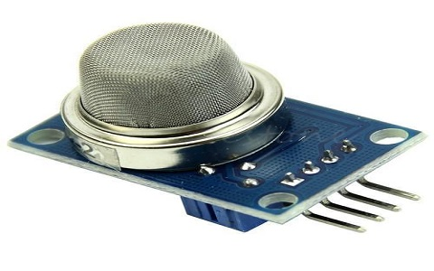

1. NoduMCU OR ESP8266

[3] NodeMCU is a minimal effort open source IoT stage. It at first included firmware which runs on the ESP8266 Wi-Fi SoC from Espressif Frameworks, and equipment which depended on the ESP-12 module.Later, support for the ESP32 32-digit MCU was added.

NodeMCU is an open source firmware for which open source prototyping board plans are accessible. The name "NodeMCU" joins "hub" and "MCU" (miniature regulator unit).The term "NodeMCU" carefully talking alludes to the firmware instead of the related advancement packs.

Both the firmware and prototyping board plans are open source.The firmware utilizes the Lua scripting language. The firmware depends on the eLua project, and based on the Espressif Non-operating system SDK for ESP8266. It utilizes many open source projects, for example, lua-cjson and SPIFFS.Due to asset limitations, clients need to choose the modules applicable for their task and construct a firmware custom fitted to their necessities. Backing for the 32-bit ESP32 has likewise been executed.

The prototyping equipment commonly utilized is a circuit board working as a double in-line bundle (Plunge) which incorporates a USB regulator with a more modest surface-mounted board containing the MCU and radio wire. The decision of the Plunge design takes into consideration simple prototyping on breadboards. The plan was at first dependent on the ESP-12 module of the ESP8266, which is a Wi-Fi SoC incorporated with a Tensilica Xtensa LX106 center, broadly utilized in IoT applications

Below the image is ESP8266:

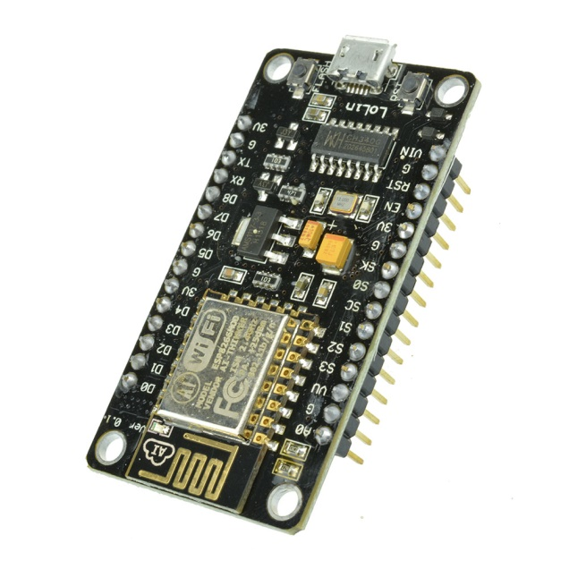

1. ESP8266 ARDUINO CORE

[3] As Arduino.cc started growing new MCU sheets dependent on non-AVR processors like the ARM/SAM MCU and utilized in the Arduino Due, they expected to adjust the Arduino IDE so it would be moderately simple to change the IDE to help substitute toolchains to permit Arduino C/C++ to be gathered for these new processors. They did this with the presentation of the Board Administrator and the SAM Center. A "center" is the assortment of programming parts needed by the Board Chief and the Arduino IDE to assemble an Arduino C/C++ source record for the objective MCU's machine language. Some ESP8266 lovers built up an Arduino center for the ESP8266 WiFi SoC, prominently called the "ESP8266 Center for the Arduino IDE".This has become a main programming advancement stage for the different ESP8266-based modules and improvement sheets, including NodeMCUs.

1. THINKSPEAK

[4] As per its engineers, "ThingSpeak is an open-source Web of Things (IoT) application and Programming interface to store and recover information from things utilizing the HTTP and MQTT convention over the Web or by means of a Neighborhood. ThingSpeak empowers the formation of sensor logging applications, area following applications, and an interpersonal organization of things with notices.

ThingSpeak was initially dispatched by ioBridge in 2010 as a help on the side of IoT applications. ThingSpeak has incorporated help from the mathematical processing programming MATLAB from MathWorks, permitting ThingSpeak clients to break down and imagine transferred information utilizing Matlab without requiring the acquisition of a Matlab permit from Mathworks. ThingSpeak has a cozy relationship with Mathworks, Inc. Indeed, the entirety of the ThingSpeak documentation is fused into the Mathworks' Matlab documentation webpage and surprisingly empowering enlisted Mathworks client accounts as legitimate login accreditations on the ThingSpeak website.The terms of administration and protection strategy of ThingSpeak.com are between the concurring client and Mathworks, Inc.

OUTPUT OF THINKSPEAK

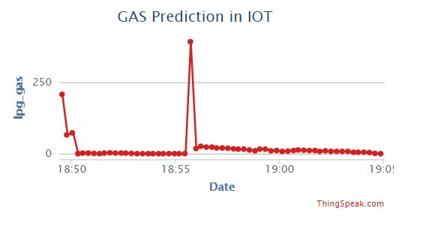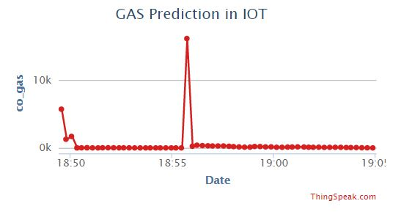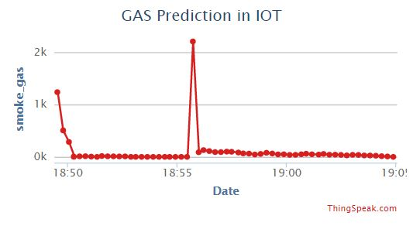

1. FLUTTER

[5] Flutter is a UI tool stash for building quick, lovely, locally accumulated applications for versatile, web, and work area with one programing language and single codebase. It is free and open-source. At first, it was created from Google and now oversees by an ECMA standard. Vacillate applications use Dart programming language for making an application. The primary rendition of Shudder was declared in the year 2015 at the Dart Designer Culmination. It was at first known as codename Sky and can run on the Android operating system. On December 4, 2018, the primary stable form of the Vacillate system was delivered, signifying Shudder 1.0. The current stable arrival of the structure is Shudder v1.9.1+hotfix.6 on October 24, 2019.

As a rule, making a versatile application is a perplexing and testing task. There are numerous systems accessible, which give superb highlights to create versatile applications. For creating portable applications, Android gives a local system dependent on Java and Kotlin language, while iOS gives a structure dependent on Objective-C/Quick language. Hence, we need two unique dialects and structures to create applications for both operating system. Today, to defeat structure this intricacy, there are a few systems have presented that help both operating system alongside work area applications. These kinds of the structure are known as cross-stage improvement apparatuses. It saves a great deal of time and advancement endeavors of engineers. There are a few devices accessible for cross-stage advancement, including online apparatuses, like Ionic from Drifty Co. in 2013, Phonegap from Adobe, Xamarin from Microsoft, and Respond Local structure Facebook. Every one of these structures has differing levels of achievement in the versatile business. In later, another system has presented in the cross-stage advancement family named Shudder created from Google. Flutter is a UI toolbox for making quick, excellent, locally accumulated applications for versatile, web, and work area with one programing language and single codebase. It is free and open-source. It was at first evolved from Google and now oversees by an ECMA standard. Vacillate applications use Dart programming language for making an application. The dart programming shares a few same highlights as other programming dialects, like Kotlin and Quick, and can be trans-assembled into JavaScript code.Flutter is mostly streamlined for 2D versatile applications that can run on both Android and iOS stages.

Blow the image is a flutter application UI:

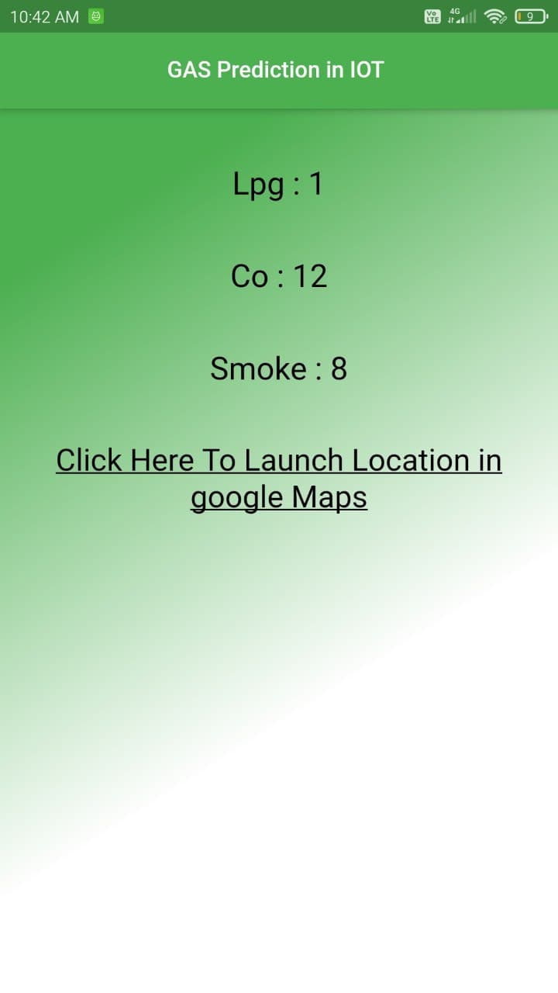

Blow the image is lanching Gmap :

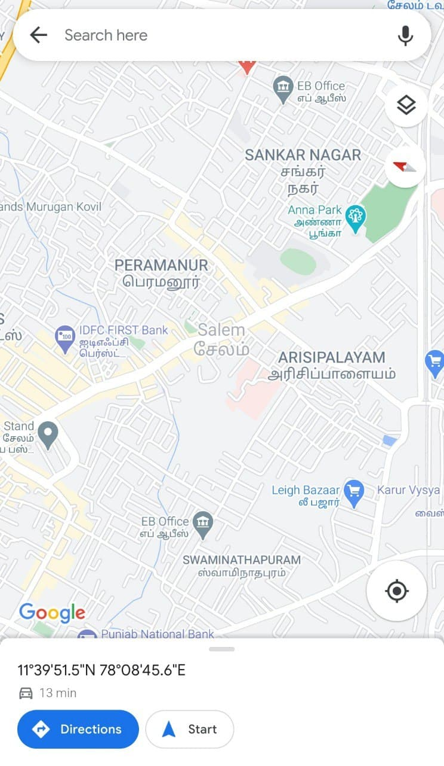

**CONCLUSIONS**

The framework gives steady checking and identification of gas spillage alongside capacity of information in data set for forecasts and examination. The IOT parts utilized aides in making the framework considerably more savvy in correlation with customary Gas indicator frameworks. The framework alarms and reacts rapidly if there should be an occurrence of gas spillage with the assistance of cautioning component and by sending notice in ripple application. The framework additionally permits client to perform examination and expectation

REFERENCES

1. Alam June 26, 2020 Gas Level Monitor On Internet Using ESP8266 & Gas Sensor https://how2electronics.com/gas-level-monitor-esp8266-gas-sensor/
2. MQ2 Gas Sensor Working and Its Applications https://www.elprocus.com/an-introduction-to-mq2-gas-sensor/
3. ESP8266 Opensource Community , NodeMCU From Wikipedia https://en.wikipedia.org/wiki/NodeMCU
4. ThingSpeak From Wikipedia, the free encyclopedia https://en.wikipedia.org/wiki/ThingSpeak

[5] Flutter Tutorial from JavaTpoint https://www.javatpoint.com/flutter

[6] https://www.iosrjen.org/Papers/Conf.ICIATE-2018/Volume-13/3-11-16.pdf